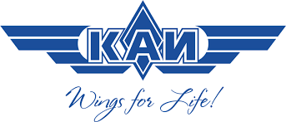
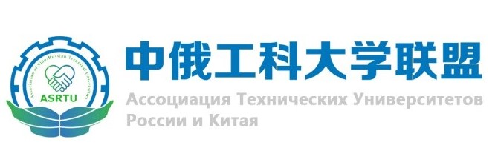

Sino-Russian Symposium
on Materials Science and Processing Technology

November 25, 2021

In order to apply for participation in the Sino-Russian Symposium on Materials Science and Processing Technology please fill in the Application Form below and submit it filled to the organizers by e-mail: kazan_2020@163.com
Thank you!

Application Form for Participants
First name
Last name/Surname
Date of birth
Citizenship
University (full name)
Job Title
Field of Study
Your e-mail address
Your mobile phone number

If you have any questions or comments please contact the organizers by the e-mail: kazan_2020@163.com

