The primary submission should be in two format :single-column or two columns.

(Title usually falls within 3 lines. All lexical words, as well as prepositions over 5 letters (including 5) should be initials in capital.)
Generation of dynamic grids and computation of unsteady transonic flows around assemblies
(Author affiliations should be listed according to the name order under the paper title. Chinese authors should put the family name first. The corresponding author should be marked with “*” on the top right.)
LU Zhiliang^{a,*}, John SMITH^{b}
ªDepartment of Aerodynamics, Nanjing Aeronautical Institute, Nanjing 210016, China
^{b}School of Electronic and Information Engineering, Duke University, Durham NC 27708, USA
Abstract
（Abstract should be about 150-200 words which can conclude the whole content of the paper (including purpose, method, results and conclusion). Equations, figures and tables, as well as references are not supposed to appear in this part. When abbreviation is firstly used, it should contain the full name with its abbreviation included in parentheses, such as “signal to noise ratio (SNR)”. Do NOT use the first person as subject. Do NOT repeat the title as the first sentence of the abstract. Simple sentence and active voice are preferred, and verb should be close to the subject.)
Low service ability of an airfield area causes frequent air traffic congestion and flight delays at busy airports. The airport system calls for capacity and efficiency improvements urgently to relieve the current congested situation. In this work, an optimization approach for the collaborative operating modes of multi-runway systems is proposed to balance the demand and capacity. Runway operating modes are classified in detail taking into consideration the airport layout, air traffic characteristics, weather conditions and other factors comprehensively. Based on the theory of runway capacity envelope, a corresponding optimization model is established by introducing the capacity loss coefficient which objectively reflects the mode switching characteristics. Then an elitist non-dominating sorting genetic algorithm is designed combined with the multi-objective optimization theory. Compared with the single runway mode, the combined runway modes bring about a striking optimization effect which results in a 38.1% reduction in the cost of flight delays and a 46.4% decrease in the quantity of adjusted flights. The approach provided can significantly enhance collaborative operating efficiency of a multi-runway system, and effectively improve air traffic punctuality.
Keywords: Transonic flow; Unsteady flow; Full-potential equation; Assembly (about 4-6 words separated with “;”; use small letters except technical terms. Abbreviations should contain full name with abbreviation included in parentheses. Selection of 1-2 from EI controlled term list is preferred:

*Corresponding author. Tel.: +86 10 82888888.
E-mail address: xxxx@csaa.edu.cn

1. Introduction
(Begin each paragraph with an equal indentation of two typing spaces.)
The computation method of unsteady transonic flow based on N-S equations should be best accurate, but to three-dimensional complex problems, it can be achieved
only on large computers, and moreover, the results are not ideal sometimes. ¹ A viscous/inviscid interaction method is an applicable one and the computation time can be reduced by two orders.
(Equations, figures and tables are usually not supposed to appear in this part.)
2. Computation scheme
2.1. Governing equation
2.1.1. Principle
The unsteady full-potential equation written in a body fitted coordinate system is given by
(1)
where ρ is density, U, V, and W are the contravariant velocity components in the ξ, η, and ζ directions,means time, and J is Jacobian.
Eq. (1) is solved by the time-accurate approximate factorization algorithm and internal Newton iterations; ² body conditions and wake conditions are implicit embedded.
2.2. Generation of grids
Taking the incompressible potential flow round a cylinder for example, the stream function is
(2)
where a is radius, and the velocity of free stream. Magnifying its radius to .
3. Presentation of results
3.1. Artwork/Figure
A detailed guide on electronic artwork is available on our website:
http://www.elsevier.com/artworkinstructions
You are urged to visit this site; some excerpts from the detailed information are given here.
Formats
Regardless of the application used, when your electronic artwork is finalized, please "save as" or c-onvert the images to one of the following formats (note the resolution requirements for line drawings, halftones, and line/halftone combinations given below):
EPS: Vector drawings. Embed the font or save the text as "graphics".
TIFF: color or grayscale photographs (halftones): always use a minimum of 300 dpi.
TIFF: Bitmapped line drawings: use a minimum of 1000 dpi.
TIFF: Combinations bitmapped line/half-tone(color or grayscale): a minimum of 500 dpi is required.
If your electronic artwork is created in a Microsoft Office application (Word, PowerPoint, Excel) then please supply "as is".
Please do not:
• Supply files that are optimized for screen use (like GIF, BMP, PICT, WPG); the resolution is too lo-w;
• Supply files that are too low in resolution;
• Submit graphics that are disproportionately large for the content.
Color artwork
Please make sure that artwork files are in an acceptable format (TIFF, EPS or MS Office files) and with the correct resolution. If, together with your accepted article, you submit usable color figures then Elsevier will ensure, at no additional charge, that these figures will appear in color on the Web (e.g., ScienceDirect and other sites) regardless of whether or not these illustrations are reproduced in color in the printed version.
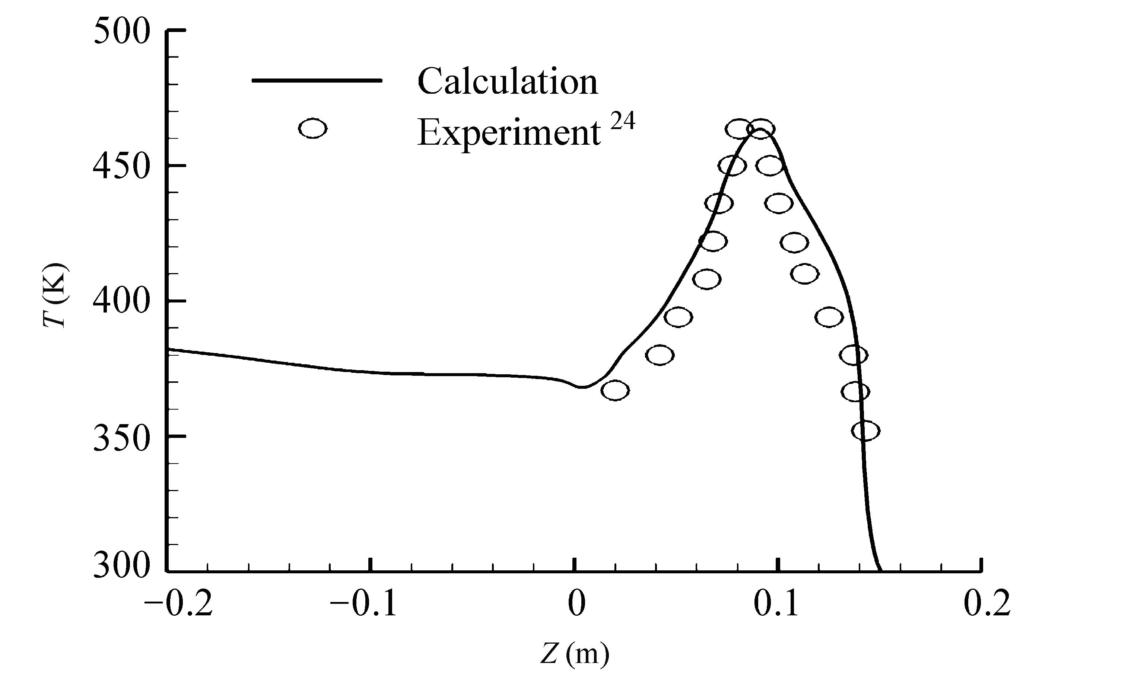
Fig. 1. Comparison between computation result and experimental data²⁴ for temperature distribution of inner wall of nozzle.

Table 1 CPU time ratio of each term.
Computational term | CPU time (%)
Flow field | 32.6
Solid temperature field | 2.2
Species concentration field | 4.3
Radiation transfer/energy field | 60.9

4. Conclusions
(Conclusion should be summarized in points without tedious description of background, method, etc.)
(1) A rapid method of the generation of boundary-fitted dynamic grids is developed in this paper, and the method of Viscous/Inviscid Interaction is used to compute the unsteady aerodynamic forces on wing/missiles and wing/body with control surfaces.
(2) The computation results are in agreement with experimental data.
Acknowledgement
The authors are grateful to Prof. Smith for discussions and A. Paytan for providing data. They also thank the anonymous reviewers for their critical and constructive review of the manuscript. This study was co-supported by the Open Fund of Key Laboratory of Power Research of China (No. *****) and the National Natural Science Foundation of China (Nos. ****** and ******).
References
Text: Indicate references by superscript numbers in the text. The actual authors can be referred to, but the reference number(s) must always be given.
List: Number the references in the list in the order in which they appear in the text.
Examples:

Reference to a journal publication (Journal names should be abbreviated, but if you are uncertain, keep it in full name)
1. Van der Geer J, Hanraads JAJ, Lupton RA. The art of writing a scientific article. J Sci Commun 2000;163(1):51–9.
Reference to a book
2. Strunk Jr W, White EB. The elements of style. 3rd ed. New York: Macmillan; 1979. p. 5-10.
Reference to a chapter in an edited book
3. Mettam GR, Adams LB. How to prepare an electronic version of your article. In: Jones BS, Smith RZ, editors. Introduction to the electronic age. New York: E- Publishing Inc.; 1999. p. 281–304.
Conference proceedings
Harnden P, Joffe JK, Jones WG, editors. Germ cell tumours V. Proceedings of the 5th germ cell tumour conference; 2001 Sep 13-15; Leeds, UK. New York: Springer; 2002.
Conference paper
Christensen S, Oppacher F. An analysis of Koza's computational effort statistic for genetic programming. In: Foster JA, Lutton E, Miller J, Ryan C, Tettamanzi AG, editors. Genetic programming. EuroGP 2002: Proceedings of the 5th European conference on genetic programming; 2002 Apr 3-5; Kinsdale, Ireland. Berlin: Springer; 2002. p. 182-91.
Scientific or technical report
Russell ML, Goth-Goldstein R, Apte MG, Fisk WJ. Method for measuring the size distribution of airborne Rhinovirus. Berkeley (CA): Lawrence Berkeley National Laboratory, Environmental Energy Technologies Division; 2002. Report No.: LBNL49574.
Dissertation
Borkowski MM. Infant sleep and feeding: a telephone survey of Hispanic Americans [dissertation]. Mount Pleasant (MI): Central Michigan University; 2002.
Patent
Pagedas AC, inventor; Ancel Surgical R&D Inc., assignee. Flexible endoscopic grasping and cutting device and positioning tool assembly. United States patent US 20020103498. 2002 Aug 1.
Journal article on the Internet
Abood S. Quality improvement initiative in nursing homes: the ANA acts in an advisory role. Am J Nurs [Internet]. 2002 Jun [cited 2002 Aug 12]; 102(6): 51-9. Available from: http://www.nursingworld.org/AJN/2002/june/Wawatch.htmArticle
Article not in English
Liu JY. An improved SST turbulence model for hypersonic flows. Acta Aeronautica et Astronautica Sinica 2012;33(12):2192-201 [Chinese].
Monograph on the Internet
Foley KM, Gelband H, editors. Improving palliative care for cancer [Internet]. Washington: National Academy Press; 2001 [cited 2002 Jul 9]. Available from: http://www.nap.edu/books/0309074029/html/
Homepage/Web site
Cancer-Pain.org [Internet]. New York: Association of Cancer Online Resources, Inc.; c2000-01 [updated 2002 May 16; cited 2002 Jul 9]. Available from: http://www.cancer-pain.org/

Note shortened form for last page number. e.g., 51–9, and that for more than 6 authors, the first 6 should be listed followed by ‘et al.’
(In principle, the corresponding author’s biography is essential and others are not and the letters of family name are all in capital form.)

LU Zhiliang received the B.S. and M.S. degrees in mechanical engineering from Nanjing Aeronautical Institute in 1984 and 1987 respectively, and then became a teacher there. His main research interests are ….
E-mail: lulu213@yahoo.com.cn

John SMITH is a Ph.D. student at school of automation, Duke University. He received his B.S. degree from Wuhan University in 2008. His area of research includes…
E-mail: wuhanujogn@sina.com

Alice S.L. ZIONBER is a professor and Ph.D. supervisor at college of mechanical engineering, Cambridge University, Cambridge, U.K. She received the Ph.D. degree from the same university in 1970. Her current research interests are…
E-mail: lzlsax@jlonline.com
Appendix
(Appendix is put behind biography unless otherwise specified. If there is more than one, order them with capitalized letters. If there are equations, order them with letters and numbers, such as “(A1)” and “(A2)”.)

